DATA ANALYTICS WITH TABLEAU

**ASSIGNMENT 4**

**Name:- Patrurla Prasanth**

**Roll number:- 20PC1A0516**

**College name:- Vizag institute of technology**

**Track:- Data analytics with tableau**

***FIXED LOD EXPRESSION***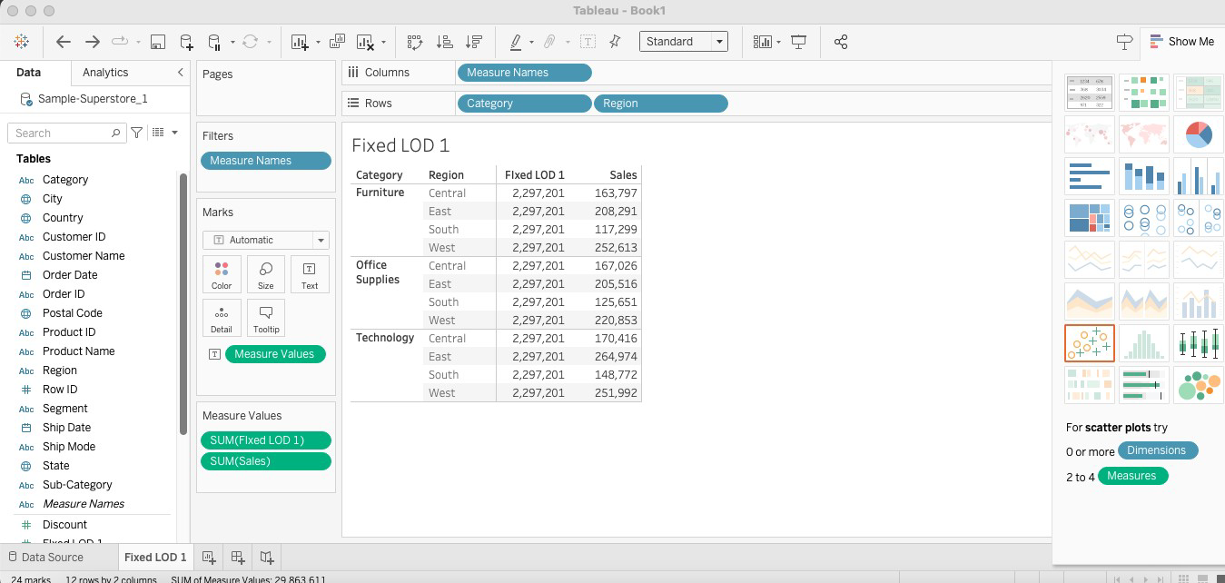

***EXCLUDE LOD EXPRESSION***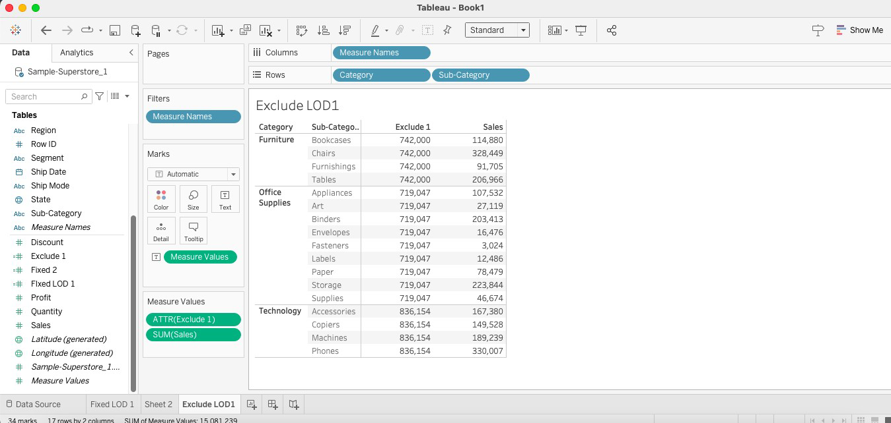

***FILLED MAP***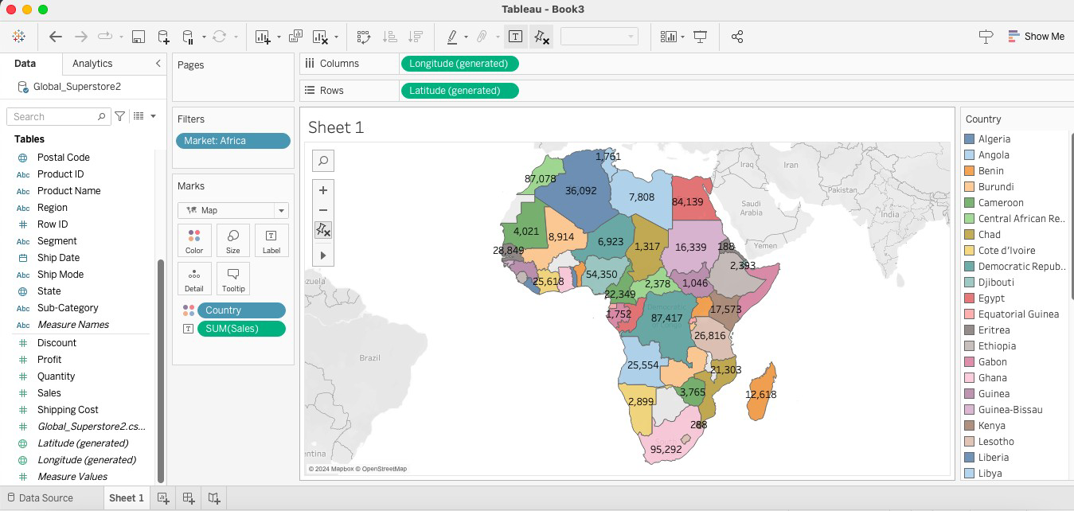

***SYMBOL MAP***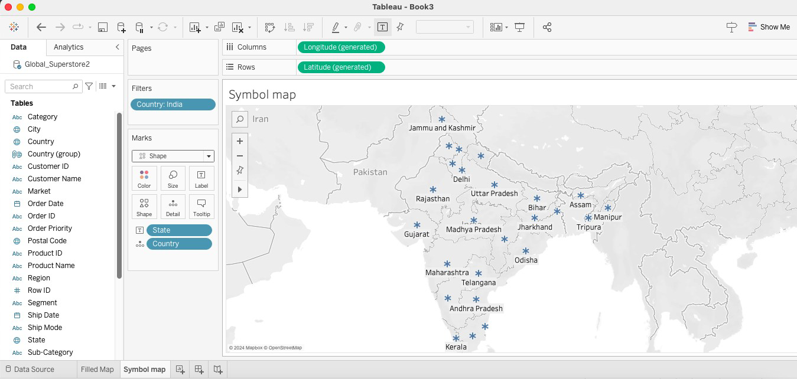

***TOP N PARAMETER***